**Tugas7**

**(PHP)**



**Disusun Oleh :**

Arief Nauvan Ramadha

Junior Web Developer A

**PELATIHAN VSGA**

**JUNIOR WEB DEVELOPER**

**DIGITAL TALENT SCHOLARSHIP**

**2021**



|  |  |  |
| --- | --- | --- |
| **SOAL** |  |  |
| **JAWABAN (V / X)** | V | X |



|  |  |
| --- | --- |
| **SOAL** | **JAWABAN (V / X)** |
|  | V |
|  | X |



|  |  |
| --- | --- |
| **SOAL** | **JAWABAN (V / X)** |
|  | X |
|  | V |



|  |  |
| --- | --- |
| **SOAL** | **JAWABAN (V / X)** |
|  | V |
|  | X |
|  | X |



|  |  |  |  |
| --- | --- | --- | --- |
| **SOAL** |  |  |  |
| **JAWABAN (V / X)** | X | V | X |



|  |  |  |
| --- | --- | --- |
| **SOAL** |  |  |
| **JAWABAN (V / X)** | V | X |



|  |  |  |
| --- | --- | --- |
| **SOAL** |  |  |
| **JAWABAN (V / X)** | V | X |



|  |  |  |
| --- | --- | --- |
| **SOAL** |  |  |
| **JAWABAN (V / X)** | V | X |



|  |  |
| --- | --- |
| **SOAL** | **JAWABAN (V / X)** |
|  | V |
|  | X |



|  |  |  |  |
| --- | --- | --- | --- |
| **SOAL** |  |  |  |
| **JAWABAN (V / X)** | X | V | X |



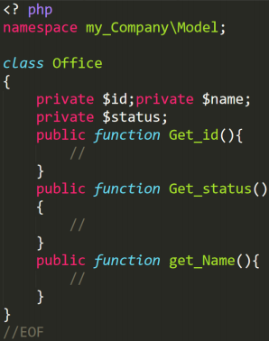

|  |
| --- |
|  |
|  |



Buatlah sebuah fungsi bagi pada PHP untuk menangani permasalahan pembagian aritmetik dengan angka 0 (divide by zero). Contoh pada pemanggilan fungsi:

● bagi(2, 2) // hasil = 1

● bagi(7, 2) // hasil = 3.5

● bagi(5, 0) // hasil = tidak valid

|  |
| --- |
|  |
|  |